July 2000

APRS Voice Alert:

Mobile HAM “radar” detector and Automatic Simplex Voice Alert System

Have you ever driven on an all day trip and never found anyone to talk to? Have you passed someone with antennas all over the roof of his car, yet, cant raise him at all? Have you tried to look through the Repeater Guide to help you find a local QSO repeater, but find the listing of 10,000 mostly silent repeaters daunting, especially while moving? Remember, statistically, one out of every 500 cars you pass is another ham! On some interstates, that is one every 10 minutes.

Now, imagine a HAM radio radar that automatically alerts you to other mobiles in simplex range, or a dual band radio with a permanent 3rd full-time nationwide Voice Alert CALL channel that is always on. What a joy such a device would be. Driving the interstates with such a radio would guarantee you a new LOCAL contact on average about every 10 minutes or so! It makes the time fly while driving…

Amazingly, such a radio does exist, in fact, two of them. Thousands of HAMs have them and most use them every day. But unfortunately, many of these owners, do not fully use the radio to its full potential on the open road and most of the rest of us are unaware of their amazing functionality, or know how to participate and join the fun. The radio, of course, is the Kenwood TH-D7A(g) Handheld or the TM-D700 APRS mobile radio shown in the figure below:
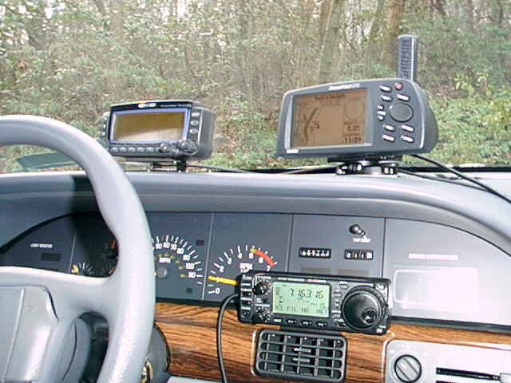
Figure 1. W4HAZ’s mobile APRS installation

Amazingly, these Radar and Voice Alert capabilities are hidden features that were not noticed until these radios had been on the market for over 2 years. And since most people categorize these radios as “for-APRS-only”, they were oblivious to the routine benefits of these special features when on the open road. All you have to do is set it up right.

To understand how it works, first you have to understand how most people use these radios. These radios are not only dual-band, but actually dual-radios with two permanent full time receivers BOTH of which can operate on VHF/UHF or even VHF/VHF at the same time. Since these radios also have built-in APRS capability, the normal arrangement is to set Band-A to the North American APRS frequency of 144.39 (with the volume turned fully down) and then Band-B can be used as a dual-band radio on either VHF, or UHF at the same time for voice QSO’s. as shown in Figure 2. This is a great way to go APRS mobile on one antenna and one radio and no TNC, no Laptop, and no cables or wires, yet still be able to run APRS and also to QSO normally.
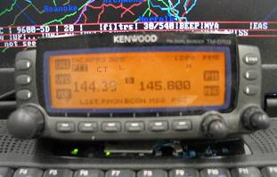
Figure 2. (shows D700 with 144.39 APRS on Band A and the TONE set to CTCSS (CT) and Bnad B is used for normal mobile operations. In this example I was monitoring the ISS Voice downlink on band B)

Since these radios came out in 1998, and after two years of driving around this way, we still had the same frustration of passing other mobiles and being totally unable to raise them by voice because there was no way to know what Voice channel they were monitoring. It is true that many mobiles put their “listening frequency” in their APRS position text so that every time they report their position, the other stations can see what channel they are monitoring. But in practice, on the open road, 90% of the time this information is just plain wrong. This is because operators dial around while mobile in distant areas and don’t take the added time to constantly re-edit their Position text every time they touch the tuning knob. Thus, they are rarely where they say they are. Many such position packets just say, “listening on 52”… yet they are actually somewhere else, or they turned the volume down due to some local interference or something..

VOICE-ALERT:

Ah ha! But in the year 2000 or so, we realized that EVERY single APRS mobile operator out there was driving around with a radio guaranteed to be ALWAYS listening on the same North American Continent wide channel, 144.39. The only problem was they all have the volume turned completely off (who wants to listen to a wall-to-wall packet channel while mobile?). Well, it only takes about a second’s thought to realize that if we simply turned up the volume to normal level, and set CTCSS-100 (136 in Europe), then the speaker would still be ALWAYS QUIET, but if someone in simplex range did want to call us, then he could do so with PL-100 and we would always hear the call! Think of it as a 3rd radio in the car. Always on a Continent wide reserved channel, Always listening for simplex calls, and yet completely silent at all other times. We called this great concept “Voice Alert”.

Voice Alert works perfectly for simplex calling. If you are ever in simplex range of anyone running it, you can always call them by simply setting PL-100 and making a very brief call on 144.39 and suggesting a QSY frequency. He WILL hear you. But there are two very important considerations:

- Your call must be brief (you are sharing the channel with hundreds of packets)
- You must announce “Voice Alert” in your call.

If you don’t say “calling on Voice Alert”, the other operator (who rarely gets a voice-alert) will hear your voice and will just assume he heard you on the other channel of his radio. He will press PTT and answer you, but since he is still on his normal Band-B, you will not hear him, and he will not be able to raise you, and so communications may be lost. But if you ALWAYS include “voice alert” in your voice call, then he immediately knows to push his BAND-A button to switch to BAND-A before he responds.

His response should always be something like “Roger, please QSY to my voice channel of ABC.XYZ”.
Thus Voice-Alert takes up only about 4 seconds of air time, yet establishes a common frequency for the continued voice contact. Never continue to QSO by voice on 144.39. It is discourteous to other users of the channel because it may block some of their packets..

MOBILE HAM RADAR:

OK, so Voice Alert is a magic always-on-always available voice calling channel for simplex use, but now how do you know when you are in range of another Voice-Alert mobile? Well, this is a freebee and what I call the HAM RADAR. Remember, that the reason he is on 144.39 in the first place is for APRS. And as a mobile APRS station with a TNC built into the radio, he is transmitting a short 0.5 second data burst about once every 1 to 3 minutes or so. Well, his packets are just like everyone else’s on the channel that you don’t want to hear, but with one distinction. That is, if he is Monitoring with Voice-Alert, with CTCSS-100 set (136 in Europe), then he is also Transmitting his packets with PL-100!

Thus, anyone else that is running Voice-Alert that is in simplex range of him, will hear his occasional packet and will instantly be alerted that there is another Voice-Alert mobile in simplex range. A Mobile Ham Radar! To those who haven’t tried it, many think, “I’m not going to listen to Packet while driving” and reject the concept out-of-hand. But I encourage you to not knock it till you have tried it or at least fully thought it through. Remember, that although what you hear on 144.39 in most areas is almost 100% wall-to-wall packets, these packets are usually 99.99% distant packets from digipeaters or other fixed stations and none of them will have PL-100. During my 30 minute commute, I may only hear 4 Voice-Alert packets total, and then only if Skip has gotten in his car and passes me!

First of all, how many other Voice-Alert mobiles are within range of you? Probably ZERO, 99.99% of the time. OK, what do you hear the other 0.01% of the time? Only a single SHORT packet, once every 1 to 3 minutes and ONLY if someone else running Voice Alert is in simplex range. If you are passing each other at 60 MPH each, you will not be in simplex range for more than about 3 to 5 minutes maximum anyway. Think of these few packets you hear as “pings” from neighbors wanting to chat. If you don’t want to chat, then turn your Voice Alert off. Leaving it on, is like calling CQ automatically to other Voice Alert mobiles.

VOICE ALERT FOR EVERYONE:

Now we get to the heart of this subject. For the last three years, the very small minority of APRS users have been using Voice Alert as a neat way to meet people out on the open road or even in their local commute. Three of us in my county run Voice Alert always, and when we are on the road in the morning headed for work, its always nice to hear a little Beep from Skip or Todd when they start their engine in the morning to get underway. Sometimes it takes 10 minutes for the Round-Table-2m commuter voice repeater to get around to us, but with Voice Alert, if we have something for the other, we can instantly say “Hey Todd, call me on 146.52” or something without having to wait for our turn on the voice net.

OK, so this is an “APRS thing” right? No. What we just realized during a 1600 mile round trip on I-81 that goes for 600 miles through Virginia and Tennessee without a single city, is that Anyone can use Voice-Alert to detect someone else in range. That is, if you are mobile, can’t raise anyone on 146.52, and don’t have anything else for your single channel voice radio to do, then just rest it on 144.39 CTCSS-100 and your “radar” receiver will be on. If any other APRS Voice-Alert mobile gets in range of you, his “pings” will wake you up for a nice local simplex QSO. So, even though only the APRS Voice-Alert mobile stations will be “pinging”, there is no limit to how many others can be listening. And since most serious distant travelers run APRS anyway, the chances are good you will run into someone using it.

KILLING THE GOLDEN GOOSE:

Notice, that ALL voice alert stations are guaranteed to have an OPERATOR PRESENT (someone has to drive the car). It should be noted that the one thing that will absolutely kill the fun, convenience and practicality of Voice Alert is for someone that is STATIONARY to configure for Voice Alert. Yes, he is welcome to listen on 144.39 with CTCSS 100 so that he can hear mobile’s pass by simplex, but he simply must not transmit any packets with PL 100 or he will become such an irritant to everyone in range that they will turn off Voice Alert and all is lost in that area.

In Washington DC, for example, there is a station running voice alert 100% of the time. This means whenever you are in town, you will hear a packet every minute over a very large area (his base station antenna has 10 times the coverage of a mobile). So I turn down my Band A voice Alert volume and most of the tim, forget to turn it back up when I leave Washington DC. Thus, he has killed voice alert in that area. Oh, and if you try to raise him, there is never any answer, because he is not home.

Conversly, a mobile is 1) Guaranteed to have an operator, 2) who is listening, 3) is always moving when operating, so he does not QRM the same area continuously, and 4) his PL 100 packets are doing what they are supposed to, that is, alerting you to his passing presence.

WHATS WRONG WITH 52?

So how is this different than 146.52? Easy. With combined passing velocities of almost 140 MPH, two passing mobiles will only be in simplex range of each other for about 5 minutes or less. Unless both of you are calling “CQ-52” every 2 minutes or so, you may pass in the night and never know the other person was in range. Also, you cannot run CTCSS on 146.52 or you won’t hear anyone. Thus, your radio does open squelch when you encounter any external QRM. Your reaction is naturally to turn the volume down. This is another great way to miss a QSO. You may drive for hours, not remembering that you turned the volume down. But with CTCSS-100 on 144.39, you will never hear any QRM. The only thing you will hear will be others like you. Yes, QSY to 52 for the QSO, but use the HAM Radio Voice Alert RADAR on 144.39 as the alert!

HOW IT WORKS:

Notice, that this only works easily with radios that have their TNC’s connected to the discriminator in front of any CTCSS Squelch systems. The Kenwood D7 and D700 radios work perfectly this way due to their built-in fully integrated APRS TNC’s. This is because the TNC’s listen to the radio prior to the CTCSS tone squelch system so that whether or not the CTCSS is set, will not affect normal APRS operation in any way. The only thing impacted by CTCSS-100 is the speaker. Thus, it works perfectly for Voice, and perfectly for packet at the same time. Other APRS mobiles that use external TNC’s cannot set CTCSS-100 without killing their packet receive capability I their TNC is connected to the speaker. However, the serious mobile traveler can easily overcome this restriction if he uses the external discriminator connector on his radio for his external TNC. This way, his TNC also can hear all packets prior to the operation of the CTCSS tone squelch system which only impacts the speaker. In this way, he too can run Voice-Alert with CTCSS-100 muting his speaker while allowing APRS mobile packet to work as well.

But it is important to note that a direct discriminator (or 9600 baud data connection) in many radios does not have the normal FM de-emphasis circuit. Thus, it will skew the packet tones and degrade performance unless you add a resistor and capacitor to de-emphasize the audio before getting to the TNC. Fortunately, many TNC’s have an internal jumper labeled something like “audio equalization” which can be configured to add the de-emphasis inside the TNC with no hardware mods other than moving the jumper. Some TNC’s may work OK as is with the discriminator also. You may as well give it a try!

VOICE ALERT RULES:

The tremendous power of APRS Voice Alert also carries with it some responsibilities of proper operation. The rules are simple and should be obvious to anyone who thinks about how the system works:

- APRS Voice Alert is for “ATTENDED OPERATIONS ONLY”. Never leave it on unattended.
- An unattended Voice Alert station is a NUISANCE to everyone for miles around.
- NEVER transmit PL-100 packets unless you are ACTIVLEY LISTENING with CTCSS.
- Voice-Alert is a calling channel ONLY. QSY immediately to a normal voice channel.
- ALWAYS say “voice alert” in any PL-100 voice transmission to minimize confusion on receipt
- Use CTCSS-136.5 In Europe where 50Hz power mains make CTCSS-100 useless
- If you turn your 144.39 speaker volume down, then turn off CTCSS/PL-100 or turn off you packets.

Transmitting CTCSS-100 Voice Alert with your volume down is like sitting in the middle of a DX pileup calling CQ with your speaker disconnected. It is discourteous to everyone. Do not do it. If you want to turn your APCR Voice Alert volume down, then turn off CTCSS first.

VOICE-ALERT and APRS:

Notice that none of this article has said anything about the mobile use of APRS and the contents of the packets. Entire Encyclopedias of information have been written about all the joy and potential of using APRS for all Ham radio applications, both on the open road and locally so such a dissertation would be beyond the scope of this article. However, we would be remiss if we did not at least mention some of the great benefits to the traveler of having a radio with a front panel text display that can display local tactical information to the traveler.
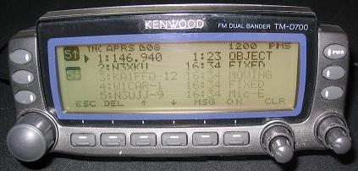
OTHER MOBILES ON APRS:

Of course the Kenwood D7 and D700’s both capture the data from all other mobiles in range and maintain a constantly sorted list of the last 40 stations heard. This list shows up on the front panel with a single press of the LIST button as shown in the figure to the right.
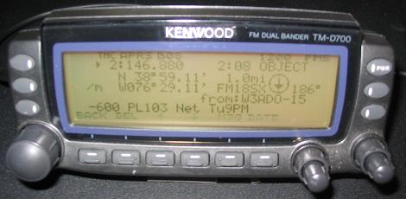
In this example there are not only 4 other stations shown in the list, but also the frequency of the local “travelers Voice Repeater” is also shown as an APRS object. This is very handy for a distant traveler entering a new area. If the operator clicks on that object, he gets additional information about that voice repeater, such as offset, PL and any regularly scheduled nets.

For more info on the display of local information on the front panel of the mobile travelers radio, please see the two web pages:

http://www.ew.usna.edu/~bruninga/localinfo.html All about the local info initiative
\\coyote\bruninga\web-docs\aprs\TWP.html Tiny-Web-Pages for HAM info on the radio display

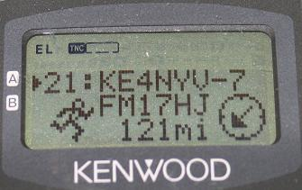
After selecting a given station from the LIST, you get a full page of information on the D700 or up to 5 additional three-line pages of information on the D7 HT as shown in the figure to the right. This one shows KE4NYV-7 is an HT operator that is 121 miles to the Southwwest. These pages show you all kinds of useful information:

- Type of ICON (Car, boat, jeep, airplane, bike, truck, van, etc)
- Distance and range from you
- Grid Square if you are interested
- Time of receipt
- Up to 20 (D7) or 28(D700) characters of status text
- His course and speed (you can see if he is approaching you are already passed)
- His LAT/LON. (usually ignored, since his posit will displayed on your GPS map automatically)

Normally, it’s a good idea to use your 20/28 characters of packet text to announce your Email address if your are a fixed station, or your Band-B voice frequency if you are mobile and keeping up with it. Otherwise, just set your text to say “144.39 PL-100 Voice Alert”.

IRLP and ECHO-LINK NODES:

A recent boon to the traveler is the worldwide network of IRLP and ECHOlink nodes that give the mobile traveler almost worldwide voice access as long as he knows where they are. But with thousands of nodes, this is becoming an almost impossible administrative task while mobile. Fortunately at our urging, both IRLP and ECHOlink have added APRS beacon capability to their software so that with the simple configurations, the node can announce itself on APRS. This way, the mobile traveler in simplex range of such a node can be alerted immediately not only to the presence of a nearby node, but also to the Frequency, PL and status of the node in real time!

A properly configured IRLP or ECHOLINK node will show up on a D700 front panel. Since the Node type and number are included in the APRS Object name, then this information shows up clearly on the station LIST and also the additional information of the Frequency, PL and Status show up when it is selected as shown in Figure 5. Like any other object in APRS, its distance and bearing from you is also shown. This is very handy for visiting mobile operators.

Figure 5. (A dual shot showing both the LIST display and the Station display with a node on it)

The node status is transmitted once every 10 minutes or once every time the node changes state. When the node is connected to another node, that information is shown as well. You might think that a once every 10 minute packet is an added load on an already busy 1200 baud channel. But this is simply not the case. These NODE status packets are only transmitted DIRECT, locally to only those mobiles in usable simplex range of the nodes site. This only adds about 0.1% additional “local” load and this kind of local, real-time usable information is exaclty what APRS was designed to do in the first place!

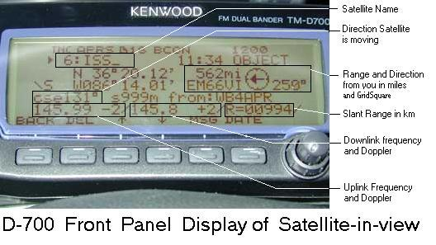
MOBILE SATELLITE OPS:

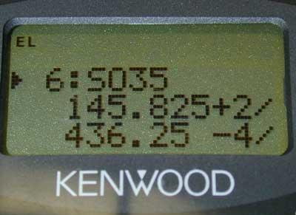
Another thing you will see on your APRS radio front panel is an occasional alert when ever an FM satellite workable from your mobile is in view. Just like for Nodes, not only is the distance and bearing to the bird calculated and shown for your station, but also the uplink an downlink frequency and instantaneous Doppler as well! These packets are transmitted by a local station running the APRSdata.exe program to all mobiles in range. Back when UO-22, Pcsat, ISS, SAREX, SUNSAT, AO-27 and UO-14 were all alive and workable from any dual band or packet mobile, these LIVE alerts to satellites in view were very handy. These days, only UO-14 is working reliably. But still, its nice to get an immediate alert whenever UO-14 is overhead and a reminder to its frequencies right there on the front panel of your radio no matter where you are and without you doing a thing to get it.

Figure 6. One of the D7’s displays showing the
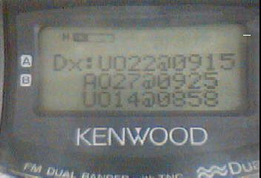
Frequency of satellite SO-35 and Doppler

But in addition to the while-in-view packets, the APRSdata engine in the area also transmits once every 10 minutes a schedule of ANY other satellites that my come into view in the next 80 minutes as shown in figure 7. This brief packet does not clutter up your APRS message list, but is captured into the D7 or D700 DX Cluster list. There, as long as the radio is not turned off, you will always find the latest schedule of any interesting satellites you might want to work in the next hour or so…

Figure 7. The D7 DX list display showing the next three satellites that will be in view in the next 80 minutes and the TIMES of the start of the next pass.

WEATHER:

Of course, since APRS was invented in 1992, local Weather has always been of particular interest to mobile operators. Any home APRS station with a weather instrument usually transmits his local weather conditions in his position packets. These are captured in the D700 or D7 lists as well and are available to the mobile operator. They not only show the distance and bearing to the home weather station , but also the wind speed and direction, temperature and rain in the last hour as shown in figure 8. This is very handy for the distant traveler to see what the weather looks like in front of him.

Figure 8. (a Weather station)

In addition to home weather stations, National Weather Service warnings and watches are also transmitted on APRS for local users. These are transmitted as bulletins or messages and will show up as shown in figure 9.

Figure 9. (a Weather Warning)

EMAIL:

Of course you can also send and receive APRS messages with the front panel of these radios. This is routine. But the more useful function of APRS messages for distant travelers is to send Email back home to family about the progress of the trip. As shown in figure 10, and APRS message addressed to the address of “EMAIL” will be picked up by the worldwide APRS system and captured by the Sproul’s WU2Z packet engine and converted into a standard Email and forwarded through the internet. If this process is successful, you will get an acknowledgement in real time.

Figure 10. (a dual shot showing the outgoing Email message and the Return WU2Z ack)…

HAMFESTS AND EVENTS:

Of course, with APRS, you will never miss a local HAM event that is in range of you. Anyone running such an event, usually puts up an APRS bulletin or OBEJCT alerting everyone in range of something happening. Figure 11 shows a HAMFEST object and a Meeting Bulletin.

Figure 11: (Shows a HAMEST object with talk in frequency listed, and a Bulletin screen announcing a
(local meeting TOINGHT and the subject)

TRAFFIC CONGESTION:

All of the above features are working and on the air in some places. But the one dream of APRS for mobile commuters is the placement of TRAFFIC objects on the map where ever traffic accidents or slow-downs occur. APRS has a special ICON just for this purpose. The ICON is a “speed sign” that appears on the map beside the road showing the speed of traffic past that point. Figure 12 shows how these would appear on the Kenwood D700. Anyone can post these objects manually, but the holy grail is to have it automated. We considered radar devices as sensors or even just capturing the speed of any other APRS operator that passed the point, but these days it should be trivial for someone to write the software to simply check the State Highway Departement’s WEB page and mine the speed data from their speed measuring system and then have that software simply convert the data to the APRS object format and send it out via an attached TNC.

Figure 12: (Shows an OBJECT labeled “Route-50W” with text saying “speed slowed to [15]MPH”)
That indicates that traffic on route 50 west bound has slowed …

CONCLUSION:

Although APRS has pretty well caught on to most of the HAMS interested in playing with computers and packet radio, we still find that most of the other 95% of ham radio operators really do not fully understand what APRS is all about and that in reality it is not just a mobile vehicle tracking system. Since the day it was invented, it has always claimed to be, and remains, a LOCAL Tactical Real Time Digital Communications system designed to deliver immediate up-to-date information to all stations in range an d particularly to the mobile operator. With the front panel displays of almost 250 pages of information on the D7 HT or the 65 or more dense pages on the D700, there is still lots of potential for delivering even more useful data to mobile travelers as they come in range of your HAM radio assets.

If you haven’t explored the advantages of Mobile APRS, then join us. If you don’t have APRS mobile, then listen for us on 144.39 Voice Alert and give us a call.

