EA467 ANDE Re-Entry Prediction and Lottery (rev1) Fall 2007

Due Date: 21 November 2007

ANDE-MAA will re-enter soon. A prize will be awarded to the USNA Student and/or Faculty/Staff member that best predicts the exact re-entry and can demonstrate the basis of his/her prediction.

ANDE-MAA was launched on 21 Dec 2006 along with RAFT and MARScom on board the Space Shuttle STS-116. After a week, the Shuttle un-docked from ISS and deployed the three satellites. The two RAFT satellites have since de-orbited in May/June, but the more massive ANDE-MAA remains in space through the end of this month. The following plot was made on 9 November. But professionals are giving predictions anywhere from the first of December to the 15th of January!

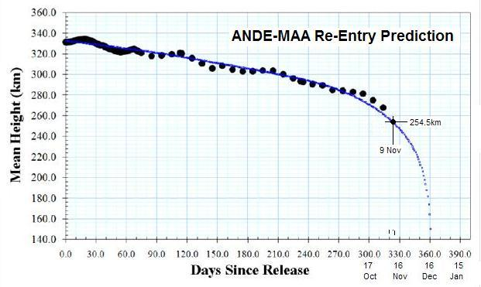

- ANDE: Using STK and current elements for ANDE predict the re-entry date and time for ANDE. Review SMAD, and all your basic knowledge of orbits, drag and decay. Do research to find the best atmospheric model to use, and real-time information on the solar activity etc.

- Check the ANDE web page and make your best assessment of the mass and drag coefficients. http://www.ew.usna.edu/~bruninga/ande.html.

- Determine a time window for your predicted re-entry date and time, from the earliest time to the latest time. Justify how you arrived at the times based on what you varied in the lifetime tool in STK.

The USNA Aerospace student who predicts the re-entry date and time closest to the actual re-entry will receive an award/prize. There will also be a Faculty and Staff category.

Throughout the final re-entry phase, amateur satellite enthusiasts around the world will be monitoring the satellite closely and feeding telemetry to our web pages. It will be interesting to see if any rise in temperature can be captured. For details, see the ANDE-OPERATIONS web page: http://www.ew.usna.edu/~bruninga/ande-ops.html

