NAVY SPACE SURVEILLANCE RADAR FENCE: Fall 2006

The Navy Space Surveillance Radar Fence has been radiating over 80 megawatts of RF power on 216.98 MHz for over 40 years across the southern United States for the purpose of detecting all objects in orbit heading over the USA. NORAD uses data from this radar system to develop the orbital elements for tenthousands of objects it must track.
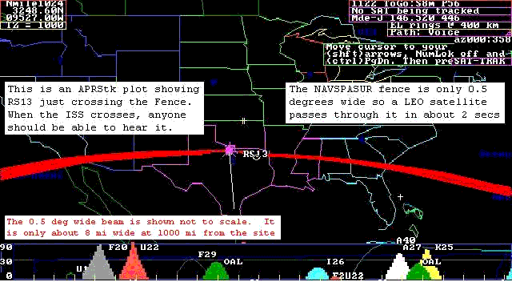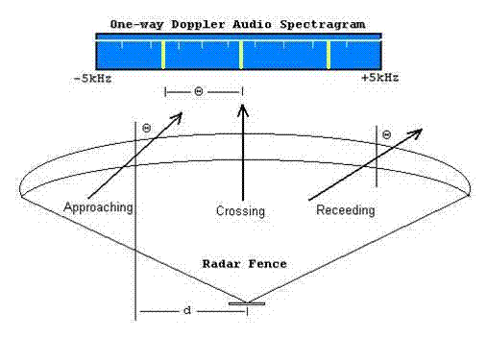

See the presentation about NAVSPASUR by a Radio Amateur who put together his own satellite tracking system (to the great interest of the Navy). See this link.
http://www.k4gfg.us/navspasur/index.html

Of course, in addition to the ten’s of thousands of manmade objects that pass thorugh the fence daily, there are Meteors as well. These leave ion trails that are so big, that just about anyone in the southern USA with a simple scanner receiver can hear these. And expecially during the annual meteor showers. This site has several recordings of typical meteor “pings” through the fence made by radio amateurs. Listen to the Leonids file and you will also hear two good pings from satellites passing thorough the fence too.
http://science.nasa.gov/newhome/headlines/ast22dec98_1.htm

SIZE MATTERS:

NAVSPASUR is a bi-static radar system with megawatt transmitters in Alabama, Texas (main site) and Arizona and receivers from South Carolina to San Diego. Since the transmitters are radiating a very narrow fan beam from the eastern horizon (91 deg azimuth) up through the zenith and down to the western horizon (271 deg azimuth) at all elevation angles to detect ALL possible objects in view instantaneously, this does spread out those megawatts to much less at any given angle on any given spacecraft. Thus there is a size below which this 80 Megawatt radar cannot detect objects. For our first lab experience, we are going for the biggest object in the sky, the Moon…

Smaller objects can easily be tracked by other tracking radars because they can focus all of their energy at one instant on one very narrow beam at one point in the sky. But it is obvious that these scanning radars have to know exactly where to look and when, to be able to detect such small objects. Thus these radars have to be scheduled, and shared, and they will never replace the original mission of NAVSPASUR; that is, to detect “unpredicted” objects such as ICBM’s heading towards the USA…

USNA RAFT Satellite:

Since most university satellite projects these days use the small 4” cubesat program at Stanford which buys launches on old Russian converted ICBM’s, it turns out that these 4” cubes are below the detectible size of the NAVSPASUR radar fence, and therefore Keplarian Elements cannot be computed nor generated until NORAD has time and schedule to use their scheduled assets to try to find these 30 to 50 new satellites after launch. Usually it takes weeks before NORAD has it all straightened out. In the mean time, Amateur Radio operators are trying their best to locate their own satellites amongst the “cloud” of their 30 to 50 fellow objects. This was the incentive for our RAFT satellites.
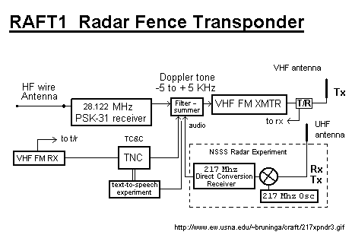
To solve this problem, (and justify a mission for our next USNA Satellite), we proposed to put a NAVSPASUR radar fence receiver on our small cubesat. This way, even though our radar cross section is too small to be detected by the radar fence, we will be able to hear our own ping as we pass through the fence. From this we can generate our own elements and track our own satellite independent of NORAD.

See the RAFT web page: http://www.ew.usna.edu/~bruninga/raft.html

LAB EXERCISE: Tracking the Moon:

Your mission during this lab, is to learn about NAVSPASUR, the RAFT mission and then to use STK to predict a time during your lab period when the Moon will pass through the NAVSPASUR Fence so that we can hear the ping here in Annapolis. The Kikapoo Texas transmitter is located at N33 32' 46" W98 45' 46" and the fan beam radiates in all elevations along the azimuths of 91.5 and 271.5 degrees true. Usually from Annapolis, we can only see hits on the 91.5 degree azimuth from Kikapoo.

