EA-467 LABsat Targeting (draft) Fall 2006

Introduction: This lab will attempt to bring together a somewhat realistic tactical exercise in targeting using space assets and our own LABsat protocols for transmitting coordinates and exercising tactical command and control. You will be given a mission and your job “If you choose to accept it” (or get an F), will be to plan a tactical mission using Blue forces and cruise missles to strike strategic assets such as bridges and key industrial support areas surrounding your target area so that you can send in ground forces and accomplish the objective. You will not only use your LABsats to enter the coordinates of your assets and transmit them into the global PCSAT downlink system, but you will also have a Red force using their labsats to maneuver the red forces and your own blue forces to try to encircle them.
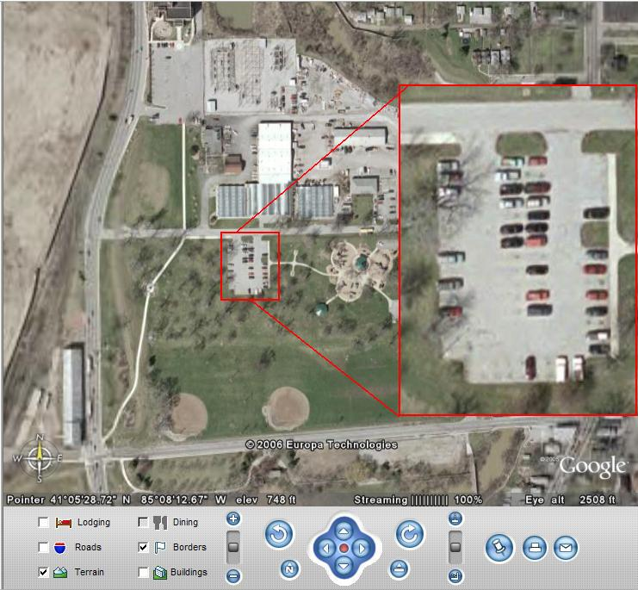
For example, here is a google-earth view of a “munitions” plan in Fort Wayne (choosen at random). Your job is to eliminate Draco Malfoy, Cruella DeVille and Lex Luthor who are terrorist arms dealers suspected to be at the plant. This view is 6 zooms out from the highest resolution, but a 3-zoom detail is provided in the inset to show the cars in the parking lot. Are our targets present today?
Typically during a mission, you will target strategic assets such as bridges to cut off lies of escape and resupply, while also providing for Blue Force entry and exit as well. This next map is zoomed out 3 more levels to show the city. Notice that cruise missiles launched by the comm. systems via your LABsats have been successful in taking out key bridges surrounding the plant.
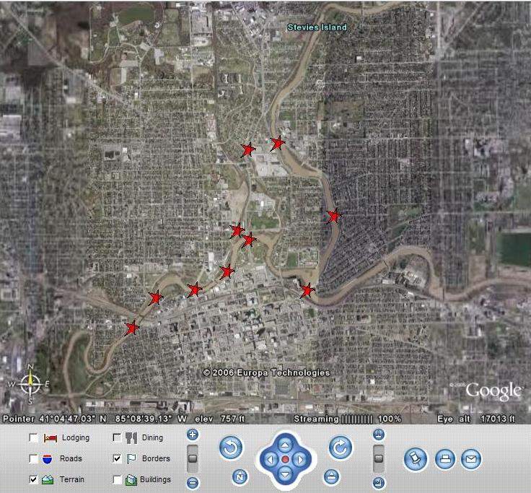

You will use all resources of the global APRS (PCSAT) internet system to your advantage during this exercise. For example. In this next image we have zoomed in on a small green jeep (K3GSI) who appears to be enroute to the centrifuge at NASA Goddard. This display is from the FINDU.COM system that combines the APRS (PCSAT) data with Google maps to give precise positioning information and plots. We will use this system heavily during this exercise.
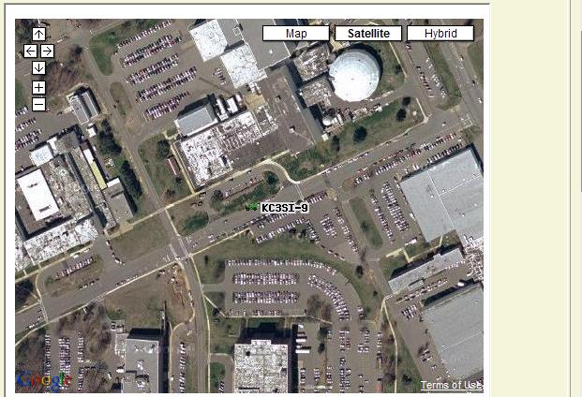

PCSAT COMMAND AND CONTROL COMMUNICATIONS SYSTEM:
The USNA PCSAT and LABsats all use a communications protocol developed here at USNA that is compatible with amateur radio systems worldwide. This system includes ground station receivers all around the world that receive any packet communications and inject them into the global APRS system where this data can be mined in any conceivable manner depending only on your own imagination and tools. Mainly the APRS system is for communicating positions of stations and objects. In this application, this can include both Blue and Red forces as well as waypoints and objects. We will use this system to create our battlespace and to move our forces and objects around the battlefield.

CRUISE MISSILE LAUNCH:
To Launch a cruise missile with your LABsat, you will simply create an object, and give it a course and speed towards the end target or any waypoints (if used). Here are the steps involved:
- Use INPUT-ADD to add your missile at your launch site, and give it a unique name. Give it a Course and speed to reach its ultimate destination or waypoint (Use great circle azimuth).
- Since your original azimuth is only an estimate, you may have to do mid-course correction. TO do this, NOTE the coordinates of a waypoint where you will make the turn, and compute a new azimuth from that location. When the missile crosses the waypoint, then activate the new coordinates and heading.
- Repeat #2 until you arrive within the target area. Then due to our inability to operate this system with only millisecond response times, you may just select the intended target and switch it’s ICON from a target to a HIT icon.
The screen shot below shows your APRS map display with 4 missles underway launched from Annapolis, Charleston, Memphis and the Great Lakes. The other objects on this map happen to be the live contacts that were using PCSAT or ARISS on the last pass. Notice that the missiles have been underway for about 8 minutes and are making progress towards their objective in Ohio.
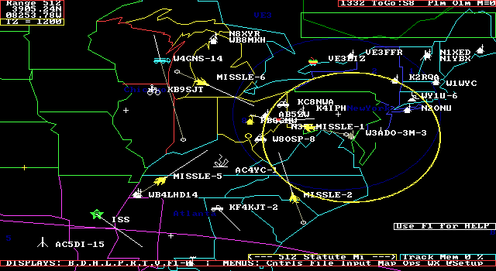
The way this works, is that your PC connected to your LABsat encodes an OBJECT in the following packet format for transmission on the local APRS frequency. The first one has the LAT/LONG of the launch point with a COURSE and SPEED appropriate at launch. The second packet has a new LAT/LONG of a waypoint and a new CSE of 222 and speed of 600 Knots. The final object packet contains the lat/long of the bridge, a HIT symbol and a comment text such as “bridge out”.

MISSIL-1>APRS,WIDE1-1:@231545z3859.11N/07629.11W$CSE/SPD Birds Away
MISSIL-1>APRS,WIDE1-1:@231550z3947.23N/07956.44W$222/600 Waypoint adjust
MISSIL-1>APRS,WIDE1-1:@231645z4218.44N/08429.33W$ Bridge out
These packets are transmitted from your LABsat, via RF out the window to the APRS digipeater (PCSAT Relay system) mounted on the top of the watertower outside Gate 8 and then from that high location, to the nearest APRS Igate (probably Baltimore) and into the internet system. From there, all kinds of assets can mine the data and present it in a variety of formats on maps.

BLUE / RED FORCES:
Blue and Red forces can be moved in the same manner as the Missiles, but are given appropriate speeds, and starting and end points. Once the exercise begins, you are not allowed to re-position your assets or create new ones at any other position than their current position. In other words, no moving at electronic warp speed. Your only control over your assets are course and speed.

INTERNET ASSETTS:
There are a variety of internet assets that mine the global APRS (PCSAT) data system. First is FINDU.COM that can show you the exact position of any asset if first know its name. The URL is as follows and will yield a map display showing the last packet heard as shown below:
http://map.findu.com/NAME
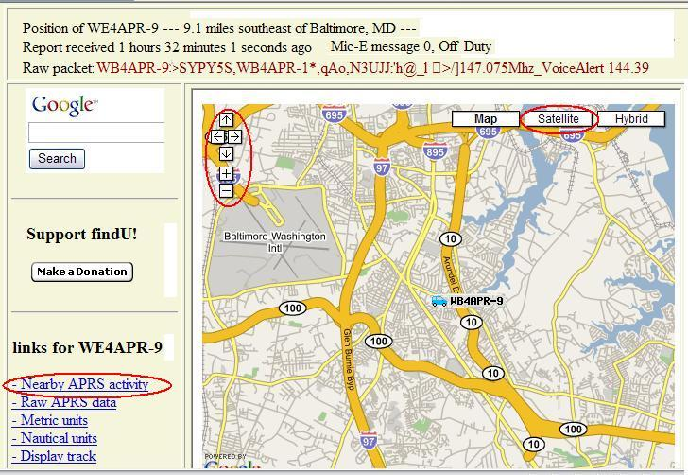
Notice Three Key areas highlighted in RED. First you can use the left-right-and zoom buttons to change your view. Next you can select the SATELLITE button to get a satellite view and or a HYBRID view which is the satellite view with the street names overlayed on it. WB4APR is my car and is always transmitting it’s coordinates live. Next click on the Nearby-APRS-Activity link:
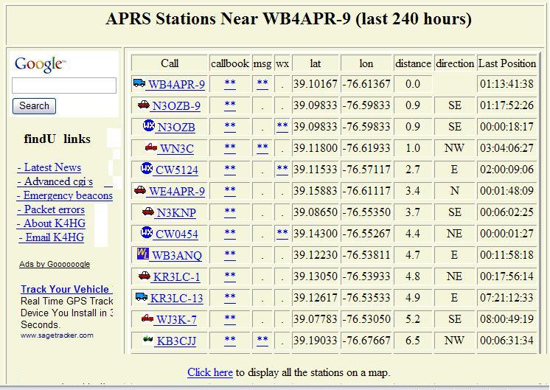
This Nearby-APRS-Activity link produces a sorted list of the 50 closest assets to your selected object. Notice, that since this is the global ham radio APRS system, most of these objects will be uninvolved civilians. You must not inflict ANY collateral damage or harass these live users in anway. But you can look down this list for any RED or BLUE forces and or missiles or other objects involved in this exercise. You can also click on the bottom button to display all stations on one map.
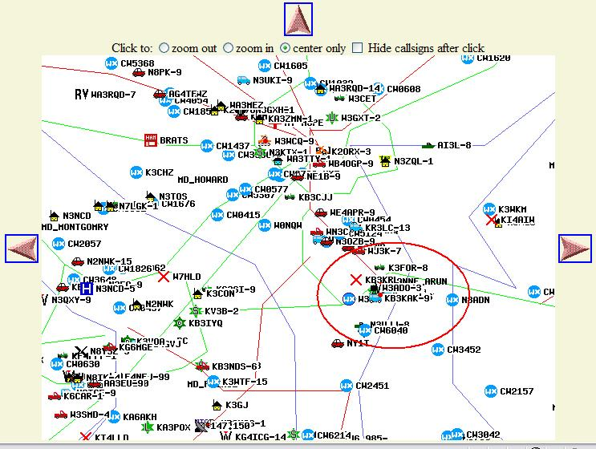
Notice that this map is a different system and much more crude. In fact, it happens to use some of my earliest stick-drawn maps that we began this system with back in 1992. The positions are precise, but the map data is very crude and imprecise. There is a pulldown menu for additional maps, but the view scale is not tied into map selection. So you may choose a detailed map, but be so far zoomed out, that the map detail is hidden by the clutter of all the stations and contacts. No one said fighting a war was going to be easy. But it does let you see the spatial relationships of all assets.

OBJECTIVES:
The objectives of this exercise are not necessarily war-gaming or tactics, but instead to let you see how simple satellite communications systems such as your LABsat can be used to transmit coordinates and information in real time and how this data can be mined and manipulated in a manner to accomplish a given objective. Further it gives some insight using the Google Earth maping system on how space assets can be used to view the battle space.

