EA467 Transmission Lines in Space Systems: (rev 3b) Fall 2006

This is a new lab for Fall 2006 to introduce students to many of the practical aspects of transmission lines in spacecraft design. And a practical section on space materials in Antenna construction.

Grouping: There are 6 areas arranged as 3 setups of ABC, 2 setups of D, 2 of E, 2 of F and 1 setup of G.

Introduction: Transmission lines are used throughout communications systems for connecting not only antennas to transmitters and receivers, but also for connecting modules and subsystems together. Any wire that approaches about 1/10 wavelength or longer will have a significant reactive impedance that is a function of frequency, and this impedance must be included in all aspects of system design. To make such conections in RF systems, then, we use transmission lines. The unique characteristics and/or common terms associated with transmission lines that have an impact on design are as follows:

Impedance - All lines have a characteristic impedance (Zo). When the line is terminated on both ends by impedances that match this characteristic impedance, then maximum power transfer takes place. Transmission lines come in a few typical standard impedances, 50, 75 and 300 Ohms for example. Typical small lines for 50 ohms are RG-58 and for 75 ohms are RG-59. 300 ohm lines are balanced lines and are called “twinlead”.

Loads - The impedance of any device connected to a transmission line can be described by the real and reactive components of its impedance, R + jX in Ohms. Usually you want loads to present only a real R resistance and matched so that maximum power is transferred and minimum power is reflected.

Standing Wave Ratio (SWR) - Mismatched lines result in reflections and this causes standing waves,. The peaks and minimums in these standing waves cause greater losses than in a matched line. The SWR is a good quantitative measure of the amount of mismatch in the line.

Loss - All lines have loss, and so the objective of system design is to minimize the effects of those loses. Low loss lines are very expensive and usually big. Lines are typically kept as short as practical to minimize loss.

Length - The length of a matched line can be any length (though loss increases with length). But variations in the length of any other line (not perfectly matched, so that it has standing waves on it) can transform the impedances at both ends anywhere between a short and an open circuit just depending on length. For example, an Open line will appear as a short ¼ wave down the line. A shorted line will appear as an open, ¼ wave away. This transformation of impedance dependent on length can be used to advantage for tuning and matching lines.

Matching - The characteristic of the line to change the impedance based on wavelength can often be used in many designs to transform complex impedances at one end of a line to a more desireable impedance at the other. This is why transmission line length in any design can be very significant.

Velocity Factor – Radio waves travel at the speed of light but are slowed by the dielectric constant of the material used as an insulator in a transmission line. Typical velocity factors are 66%, 81% and 89%. This factor shortens the effective length of the line. For example, ¼ wave at 150 Mhz is 12” in coax instead of 18” in air.

Connectors – There are a few common RF connectors you should recognize. BNC are the twist-lock connectors typically seen on RG-58 and 59 (not used in space, but used throughout this lab). SMA are for smaller cables and are typically brass colored. Larger cables or higher powers use type “N” connectors (on our wattmeter and Signal Generators). A larger connector called a PL-259 is used on many consumer type radios (CB and HAM) and are often called UHF connectors though that dates back to the 1940’s when even 30 MHz was considered ultra high frequency. Now, these connectors would never be used at UHF because they are not a constant-impedance connector.
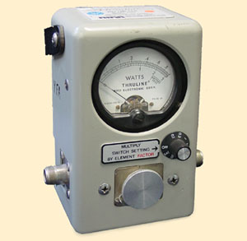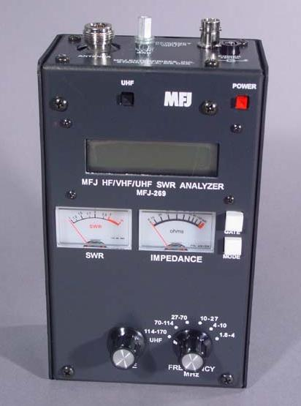

INSTRUMENTATION – SWR Bridge and Antenna Analyzer:

Because of the important of properly matched transmission lines and the effects of mismatches on system performance, the main instrument when dealing with transmission lines is the SWR bridge or directional Wattmeter. The directional Wattmeter shown above left has a reversible sensor so that the forward power and reflected power can be independently measured and the SWR computed using the relationship below left. This device is sometimes called a “bridge” because it is measuring the difference between a known impedance (50 ohms for example) and the reflection coefficient of an unknown load.
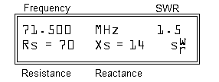

The second instrument, on the right above, is called an Antenna Analyzer. Internally it has an oscillator and SWR bridge for comparing the impedance of an attached line or load. The LCD display as shown above shows the Frequency of operation, the SWR magnitude and the Real and Reactive components of the impedance. Two analog meters also show the SWR and real impedance for easy tuning.

Part A. Characteristic Impedance: In this experiment you will measure the effect on SWR of several lines and loads to demonstrate the effects of loads and characteristic impedance as shown below.

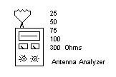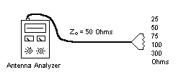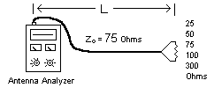
- Set the Antenna Analyzer to “Impedance R and X” by pressing the MODE key and tune to about 55 MHz. Then measure the SWR and impedance of a short, an open, a 25, 50, 75, 100 and 300 ohm resistor connected directly to the analyzer. During each measurement, run the TUNE knob from about 27 to 70 MHz and notice any effects. Which one gives the closest real impedance reading to its actual value and which one remains the most constant with frequency.

- Repeat these measurements on the end of a 4 foot 50 ohm line. Compute the frequency where this line is ¼ wave in coax with a velocity factor of 66%.

- If any frequency exhibits resonance in the next step (dip in SWR to low value), record it.

- Repeat the measurements again on the end of a 4 foot or so 75 ohm line.

- Repeat them again on a very long 50 Ohm line (which has some loss). You should notice that the SWR appears to be better (lower), not because the SWR on the line is actually lower, but because the losses in the coax attenuate the reflection from the far end and this makes the SWR “appear” to be lower when in fact, it is not. This is a common error made by many newcomers to the field.
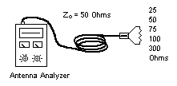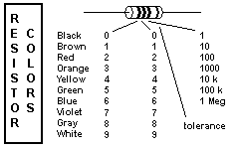
- Comment on lessons learned with respect to best impedance match and lowest SWR.

Part B. Combining Loads or Splitting Power: Very often in electronics, power on a transmission line has to be shared or combined among two or more loads. At low frequencies, where the length of the wire is very small with respect to wavelength, things can be connected in parallel with simple wires at a point. But at RF frequencies, any attempt to parallel loads must take into account the impedance of the line and its length and the transforming effects of mismatched loads.

- If you combine two 50 ohm loads with negligible line length, you get a 25 Ohm effective load and this has an appreciable mismatch. Review your readings for the 25 ohm loads as observed in Part A-1 and 2.
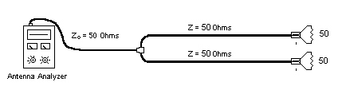
- Now use a “T” connector to connect two 4 foot 50 ohm lines with 50 ohm loads together onto your single 50 ohm line as shown above. This also causes a combined 25 ohm parallel combination and you should see about the same SWR you measured when you used only a 25 Ohm resistor. Vary the frequency and note any changes in SWR. It should remain poor across all frequencies because the mismatch at the “T” remains 25 Ohms no matter how long the length of the lines. Remember this for the next part, you cannot simply connect matched lines with a “T”.

Part C. Quarter Wave Transformers: The effect of length of a section of transmission line can move the complex impedance around on the complex plane, A quarter wave section of line will perform a 90 degree transformation of the impedance in the complex plane. This ¼ wave line can transform a short to an open, and an open to a short. But there is another simple characteristic of a ¼ line, and that is that it can transform any real impedance to a different real impedance according to the following relationship:

Zin * Zout = Zo ²

This is used very often to transform impedances for matching transmission lines. For example. If you want to transform a 100 ohm load to 50 ohms, you can use a ¼ length of 75 ohm line. A great application of this is when combining two 50 ohm antennas for increased gain (+3dB) as was attempted in part B. First connect each antenna to ¼ wave of 75 ohm line, This transforms each to 100 ohms using the above equation. Now connect the two effective 100 ohm loads in parallel using a simple “T” connector and the resulting load is 50 ohms and a perfect match for a 50 ohm system (but only at that frequency where the lines are exactly ¼ wavelength.) To validate this capability, perform the following two experiments:

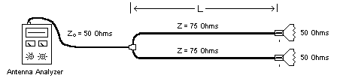

- Combine the two 50 ohm loads using a “T” connector as in part B, but with two 4’ foot 75 ohm lines as shown above. These will transform by the equation above to 100 ohms at the “T”, and with two of them in parallel, this should provide a good 50 ohm match to the Antenna Analyzer. Use the TUNE knob to find the frequency where the 75 ohm lines are ¼ wave long and give the lowest and best SWR. This should be a good match.
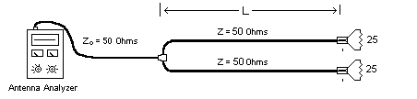
- For another example, now replace the two 75 ohm lines with two 50 Ohm lines and replace the two 50 ohm loads with two 25 ohm loads as shown above. Again, use the TUNE knob to find resonance and validate how the lines can combine the two 25 ohm loads for minimum SWR (or maximum power transfer). Of course, you are now dealing with 25 ohm loads which is unusual, but coulc be designed into some antennas if needed.

In these examples, you have built what is often called a “phasing harness” or “phasing lines” to allow you to parallel two 50 ohm loads together and still maintain a match. Notice that the length of the coax lines must be exactly ¼ wavelength at the frequency of operation for this match to occur. A phasing harness is often used on spacecraft to split or combine power from two or more antennas. Sometimes this function is packaged in a small box and called either a “splitter” or “combiner”.

- Sketch a design for a phasing harness using ¼ wave phasing lines to combine Four 50 ohm antennas to a single 50 ohm line.

Part D: Notch Filters: You can use this same ¼ wave transformation effect as a notch filter. Since a ¼ wave line that is open on one end will reflect a short to the other, you can connect this “stub” with a “T” connector and at one frequency where the line is exactly ¼ wave, the signals on the line will be shorted.
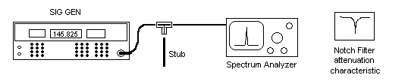
Connect the signal generator to the spectrum analyzer without any stub connected to the “T” and set both for a 0 dBm level centered at about 35 MHz. You should be able to tune the signal generator from about 20 to 60 MHz and see very little change in amplitude of the signal delivered to the spectrum analyzer.

- Now “T” in a 5 foot piece of line as shown above. The Zo of this stub does not matter. Why? Compute the frequency for which it is ¼ wave and tune to that frequency. Remember to include the shortening effect of the dielectric constant of the line (usually 66%). Tune around that frequency to find the maximum attenuation of the signal by this simple ¼ wave notch filter. What is the attenuation of this simple “notch filter”? What does this tell you about leaving unterminated lines in any test configuration?
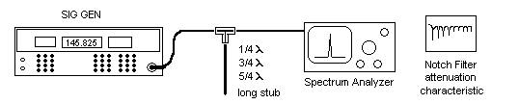
- Any line that is an odd multiple of ¼ wave will produce a similar notch at 3, 5, etc times higher frequencies (Why?). Tune to higher frequencies and you should find multiple attenuation notches. However, at higher and higher frequencies, the stub line appears “longer and longer” and so will have more and more loss in the stub. This reduces the effectiveness of the reflected “short” and so the attenuation is not as great. But this makes a nice “comb” filter for taking out all the harmonics of a particular set of frequencies. What is the depth of the notch at the ¾ and 5/4 wave frequencies?

Part E: ½ Wave Lines: Notice that no matter what impedance you place on one end of a ¼ wave line, the complex impedance at the other end can then be further transformed back to the original impedance by an additional ¼ wave line using the above equation. This means that a ½ wave line will virtually “disappear” as far as it’s characteristic impedance is concerned. You can use this special feature to get an impedance from point A to point B inside a system without worrying about matching the line impedance…. Just make the line exactly ½ wavelength long. For this exercise, you will use a transmitter and a wattmeter to measure SWR.
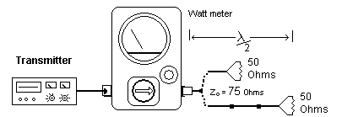
- Place the short 75 ohm coax with 50 ohm load directly on the wattmeter. Measure the SWR by reading the 29 MHz TX power in the forward and reverse direction. Compute the SWR. Compare your measured SWR to that in Part A for this mismatched line.

- Now add two additional 4’ long 75 ohm blue coax lines and measure the total length and compute the ½ wave frequency. TUNE the transmitter to that frequency and tune for minimum reflected power and then compute the SWR. Hopefully it will be close to 1.0

Part F. Cable Loss (GPS): To get higher in frequency where cable loss is more apparent, we will use a GPS receiver for this experiment out on the Plaza. Long cables waste power in transmit systems and weaken signals in receive systems. This experiment demonstrates the loss of signal and SNR using two lengths of coaxial cable at the GPS operating frequency of 1575 MHz. At this high frequency, even short cables have measurable loss.
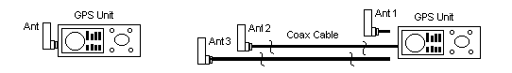
Lab Period: (Plaza)
- Connect the GPS unit directly to the external antenna and hold it clear of all objects. Allow a minute for the receiver to obtain a fix. Record the relative signal strength and position of the satellites. Assume the top line is the 0 dB reference and each line is -3 dB from the line above.
- Connect the other antenna with the 16’ length of RG-58 cable. Allow a minute for the receiver to resume lock. Record the satellite relative signal strengths and positions.
- Connect the 3rd antenna with the 16’ length of low-loss RG-8 cable. Allow a minute for the receiver to obtain lock. Record the satellite relative signal strengths and positions.
Post-Lab: Compare the measured signal losses to the expected losses and to each other. Discuss the importance of cable selection. See the chart of coax cable loss per 100 feet below. How does your data compare?
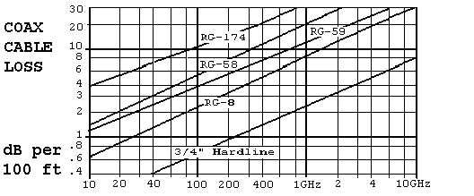

Part G. Cable Loss and Low Noise Amplifiers (LNAs): In this section you will use FLTSATCOM as a signal source to study the effects of cable loss on the signal-to-noise ratio that determines receive side performance. You will make several signal and noise measurements with and without the LNA at each end of the cable. For consistency, we will use the 6th transponder from the left of the FLTSAT channels.
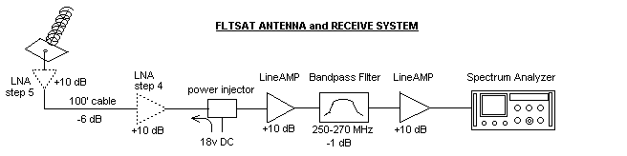
Lab Period: (Plaza/Lobby)
- With nothing connected to the Spectrum Analyzer, tune to 254 MHz with a bandwidth of 300 kHz and scanwidth of 2 MHz per division. Set the Log Reference Level to –50 dBm and Linear Sensitivity to 0 dBm. Determine the noise strength in dBm (the RMS average) of the Analyzer noise floor.
- With the LNA connected out at the antenna, point to FLTSAT 7 (220º AZ and 45º EL) Notice how the 10 signal channels are well above the noise floor (at least 16 dB or more). Observe the signal power level compared to the noise power level and thus, the Signal-to-Noise ratio (SNR). The noise level is higher now due to the noise of the amps after the antenna..
- Now move the LNA from the antenna into the lobby operating position. Connect it in front of the power injector and two line amps where the cable connectors are marked with yellow tape. Observe the noise level, signal level, and SNR. The difference here is that the cable loss is now in front of the LNA instead of after it. Comment on the lesson learned here.
- Now remove the LNA completely (re-connect the coax straight through). Observe the noise level, signal level and SNR. Comment on this observation.
- Now eliminate the gain of the two additional line amps by disconnecting the antenna cable at the BNC connector and connecting it directly to the input of the spectrum analyzer. Now observe the noise level, the signal (if any) and the SNR. Probably you cannot see the signal at all because you have lost over 30 dB of amplifier gain that was being used to get the signal above the noise floor of the spectrum analyzer and the cable loss. Comment on your observations.
- Restore the system to normal, re-connect the two 20 dB line amps and move the LNA back out to the antenna for the next group.

Transmission lines Laboratory Report: This is a simple lab. You have made lots of observations from which you can support many of the theories about transmission lines and their practical application. In each element of the lab you were told what values to collect and what results to observe. With this background, submit an individual report as follows:

- For each part of the lab, include a drawing of the setup, and a table of the observations, including comments on any of the values that may have appeared to have a sensitivity to frequency o r other variables.

- Based on your observations, write conclusions for each part relative to the principal or function that was involved. Answer all questions and comment on all salient points observed.

- Include an overall introductory section and conclusions section. Your report will be graded on how well it stands alone as a treatise on the practical aspects of transmission lines in spacecraft design as supported by your experiments.

