Antenna Patterns and Signals: The main trade-off in spacecraft communications system design is where to add the power and gain required for successful communications (ground or satellite), while allowing some margin for variations in the terrestrial and space environment and equipment.

Spacecraft: A powerful satellite transmitter can be used with a low gain antenna, but will add weight and expense to the spacecraft. Or a larger higher gain antenna can be used with a lower power transmitter, but this will decrease the antenna beamwidth and require greater pointing accuracy and complexity.

Ground Stations contend with similar issues. Smaller antennas require higher power transmitters and produce weaker received signals. Mobile platforms have antenna size and transmitter power limits. Reducing electromagnetic interference with more highly directional antennas also plays a part in ground station design.

VHF Dipole Antenna Pattern: This experiment uses a simple FM broadcast band fundamental dipole antenna to observe basic antenna gain patterns as shown below:
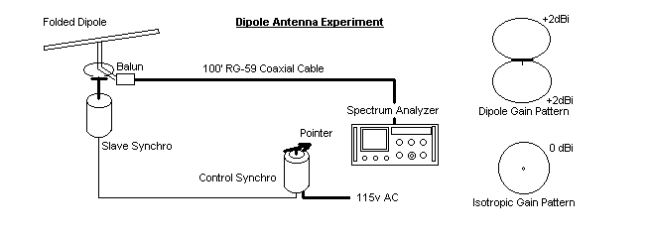
- Tune the spectrum analyzer to 98 MHz with a bandwidth of 100 kHz and scan-width of 5 MHz per division. Set the Log Reference Level to –50 dBm and Linear Sensitivity to 0 dBm. Observe the signal power of each of the dozens of FM broadcast stations and tune to center the display.
- Shift the scan-width to 2 MHz/div and observe the individual signal amplitudes while slowly rotating the dipole using the linked synchro motor dial. Notice there is significant signal variation on each station depending on the orientation of the dipole relative to that station caused by the antenna gain pattern. If you were to plot this variation in signal strength, you would see the “donut” cross section shown above.
- You can also tune the Spectrum Analyzer to a number of other signals on the air. The FM broadcast band is 88 to 108 MHz. You can see several TV signals as you go higher in frequnecy, both analog (twin carriers, Video and Audio in a 6 MHz bandwidth) and digital HDTV signals that are almost like boxes with all the energy almost evenly distributed over the same 6 MHz bandwidth as show in the examples below.
