Satellite Electrical Power Systems are one of the most important subsystems on spacecraft. Typically, solar panels are used to power all systems either directly or to charge a battery for use when the satellite is out of the sun. Our lab power system consists of a Solar panel, a regulator, a battery and a load. A voltmeter is connected to read the array voltage and an ammeter reads the current supplying the load. In this demonstration, the battery is disconnected so that the changing effects of solar angle and shading on the panel can be seen.
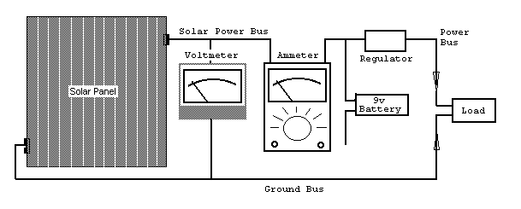
Small Panel Procedure: Power in Watts is the product of Volts times Amps. On a clear sunny day, the sun can produce about 100 watts per square foot, but solar panels are only 8 to 25% efficient. The difference in cost between the 8% and 25% cells is about 100 times!
1) You should be able to get about 50 mA on a sunny day and the volts should remain above 10 volts.
2) Tilt the panel to see how the power drops off relative to the angle to the Sun.

Big Panel Procedure: To give a better feel for the power from the sun, but also the limitations of solar power, the larger solar panel is connected to a large motor. You can see the Volts and Amps produced and can feel the power (product of volts times amps) by using your hand to slow the motor. A second motor is connected to a battery.
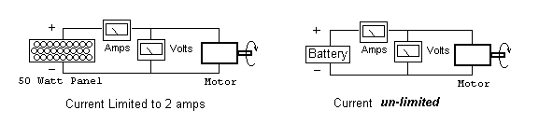
1) Use your hand to slow the shaft of the solar powered motor and notice that at a certain current, the solar panel is saturated and can produce no more power. At this point, the voltage and power drop drastically to almost zero while the current remains at its peak current capability.
2) Do the same experiment with the battery powered motor. Notice that the battery has almost unlimited capacity to deliver current. You can draw over 10 amps by stopping the motor completely.

IMAGEsat Power System: Also on the this table is one of our LABsatelites configured as an Imaging Satellite. It has an image sensor (TV camera) which can be controlled from the satellite ground station. Inside the lobby you should be able to view the image from this Imaging satellite which is running exclusively on Solar Power alone.

0 – 5 Amp Scale
0 – 10 Amp Scale

0 – 7.5 Volt Scale
0 – 15 Volt Scale

Battery Powered Motor
at 6 Volts

Solar Powered Motor
at 12 Volts

