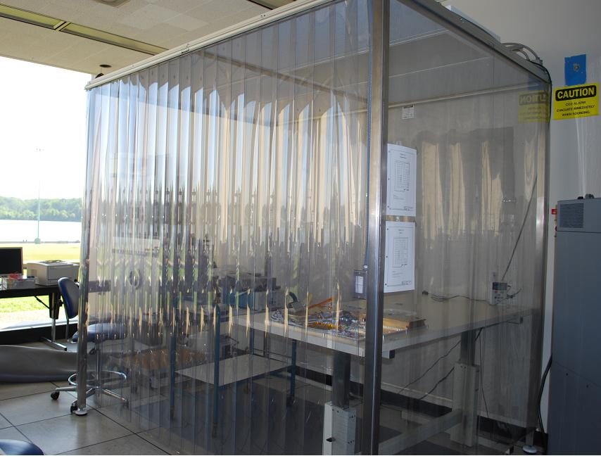
Naval Academy Satellite Lab Facilities

The Astronautic track in the Aerospace department has grown since 1990 to include most of the facilities and equipment shared by most aerospace companies and agencies. To the right you can see our 6 x 8 foot clean room. This room can maintain cleanlieness down to class 100,000 or with special care, down to 10,000.

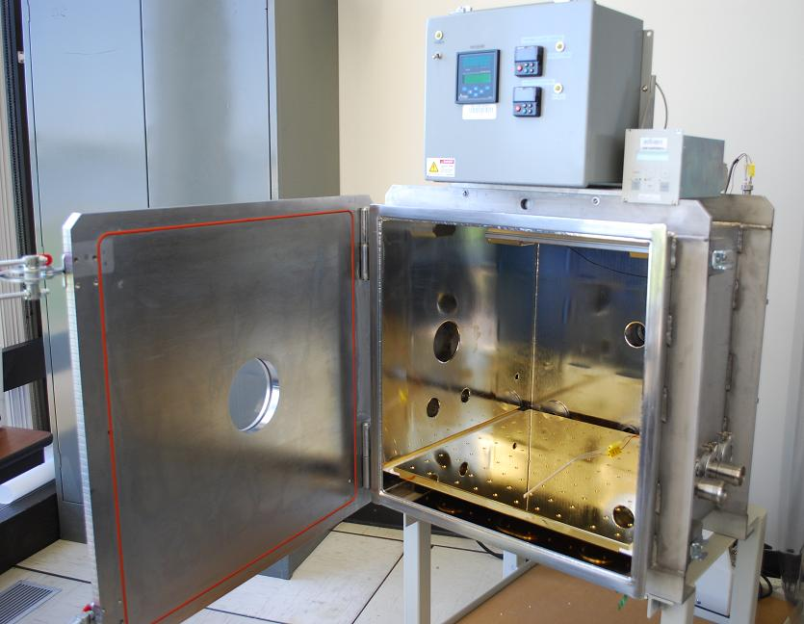

To the left is our Thermal Vacuum chamber that can simulated the vacuum of space while also providing radiant heat similar to the sun and radiateive cooling similar to the blackness of space at nearly -70 degrees C.

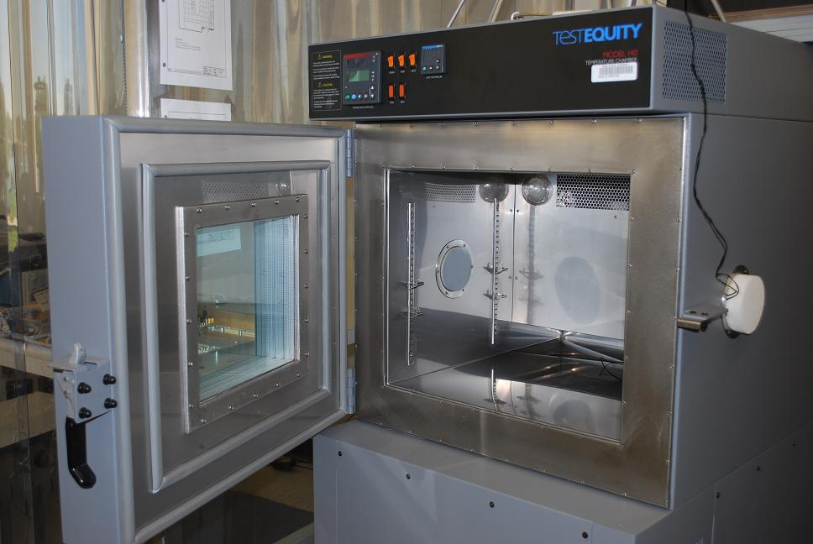
The the right is our Thermal chamber that can expose over a cubic foot of experimental volume to temparatures from -60C to over 250 C. Access ports are provided for test equipment and instruments

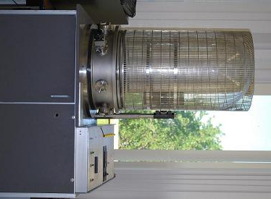

Our original Bell Jar vacuum chamber is quite useful for laboratories and demonstrations. Its clear viewing area is very practical for group demonstrations.

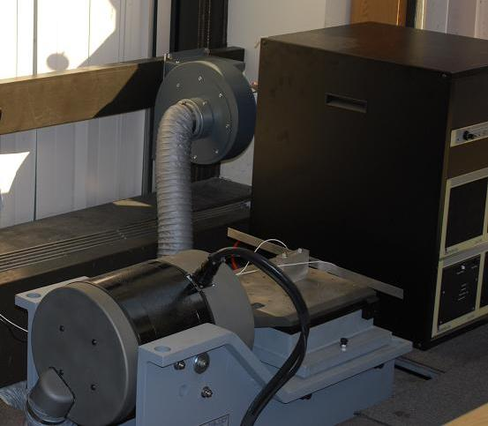

Recently we added a vibration table that can shake in one axis. Here it is shown in the horizontal position. The main shaker table can also be oriented vertically.

