SATELLITE ATTITUDE CONTROL Summer 2008

ParkinsonSAT is our next USNA Satellite Project. The mission for this satellite is a similar communications mission as many of the previous USNA satellites, but to assure maximum power, this satellite is designed to point its best solar panel always at the sun. To control the attitude of a satellite, you have to be able to push against something. In space, there are only three things to push against:
Magnetic Torque Coils: By energizing coils, a force can be developed against the Earth’s magnetic field.
Momentum Wheels: A motor can develop a force against the inertia of the mass of a wheel.
Gravity Gradient: Making a satellite with a long boom can make it align “up and down” against gravity
Reaction Thrusters: Firing small thrusters can push against expelled gas (but consumes fuel)
Solar Sail: The solar “wind” of particles coming from the sun can sometimes provide very small forces.

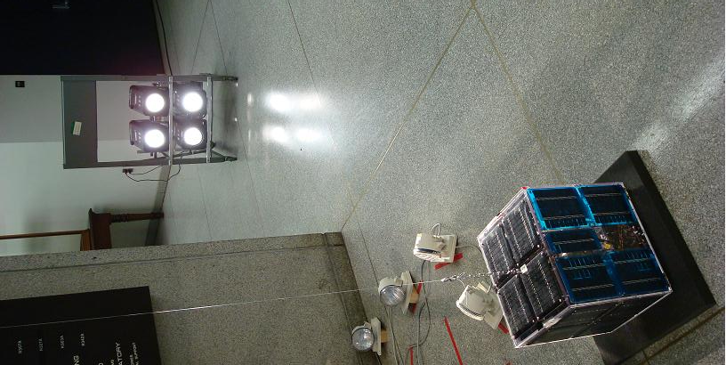
Our Parkinsonsat has two magnetic coils at right angles that can be energized to bring any of its horizontal faces toward the sun. The forces are very small and it takes minutes for the spacecraft to be able to turn its +Z face toward the sun, so it is a painfully slow demonstration to watch. Also, the wind currents as people walk past the satellite are from 100 to 1000 times stronger than any forces the satellite will experience in space.

To see how Parkinsonsat is trying to force its way to the sun, we have connected Red LED’s to the spacecraft coils so you can see which coil is energized. The coil that is energized is the coil that will bring itself towards north. We have placed our artifical sun North of the spacecraft so that it is easy to see these forces at work.

Demonstration Replay: Another way to see how the ParkinsonSAT aligns itself with the sun, is to replay one of our capture files. This file consists of about a 2 hour period when the satellite was left alone to align with the sun. It starts off with a significant spin, but then quickly dampens that spin with counter-rotating torques and once the spin drops below 5 degrees in 10 seconds, then it energizes the proper coils to turn the +Z face to the lamp.
If the Replay is not currently running, press the SPACE bar to re-start it.

