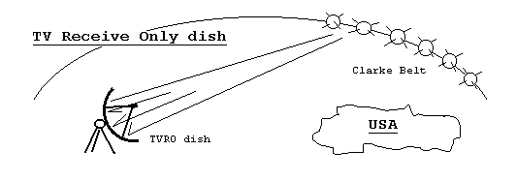
Introduction: You use satellites every day to see the weather, to talk long distance on the phone, to listen to radio broadcasts, or to watch TV. But radio and TV signals only travel in straight lines which limits the range to only a few tens of miles due to the curvature of the Earth. For greater range, we launch relay satellites in an orbit where they can relay signals over very large areas. Most are placed in fixed spots in the sky called geosynchronous earth orbits (GEO). This circular orbit above the equator at an altitude of 22,233 miles is also known as the Clarke Belt in honor of Arthur C. Clarke, the science fiction author who proposed the belt in 1945, 12 years before the first satellite. At this altitude an orbit is exactly 24 hours which matches the rotation of the Earth, so the satellite appears to be stationary to an Earthbound observer.
The GEO arc is very crowded. As of March 1999 there were over 200 satellites in the Clarke Belt with most of them over the USA or Europe. There is a limit on how close the satellites can be placed which is defined by how narrow the ground station antenna beams have to be so that channel 13 on one satellite does not interfere with channel 13 on the next satellite. The larger the dish antenna, the narrower the beam for a given wavelength. For satellite TV at 4 GHz, the wavelength is 7 cm, so a 3m dish is over 40 wavelengths across and can focus into a beamwidth less than 2 degrees wide. This is why these satellites are spaced every 2 degrees.
One way to reduce the interference between adjacent satellites is to simply have one transmit vertical waves and the other to transmit them horizontally. This is just like Polarized sun glasses. The ground antennas can be aligned to only receive the vertical or the horizontal signal. The TV Receive Only (TVRO) dish accounts for the polarized signal by rotating the feed horn 90º.
The signals you will receive on this TVRO dish are the classic Analog TV received by millions of backyard dishes across the country. You will move the antenna back and forth to learn about the beamwidth of the antenna and the polarization.

Student Activity: This dish has azimuth (compass bearing) and elevation indicators so that you can manually (carefully) aim it to the satellites. You are searching with 4 degrees of freedom, AZ, EL, Frequency, and Polarization. You will only find satellites on the Geostationary Arc.
- Aim the dish south towards the Clarke Belt and find a satellite up about 45 degrees.
- How far can the dish move (azimuth and elevation) before you lose the signal?
- Find as many satellites as you can and plot them on the Horizon View chart provided.
- Rotate the feed 90 degrees and search again to see the other satellites on the opposite polarity.
- When finished, carefully let the dish return to the horizon.

