FLEETSAT and UFO SATELLITES: Most of the Navy’s communications are provided by a constellation of geostationary satellites called FLEETSATs. These satellites operate on UHF frequencies and have been upgraded with newer satellites called UHF-Follow-On satellites or UFO’s. Since these satellites are geostationary, they appear at fixed points in the sky along the Clarke Belt and all we need to do is point an antenna up at them and we can receive the communications channels.
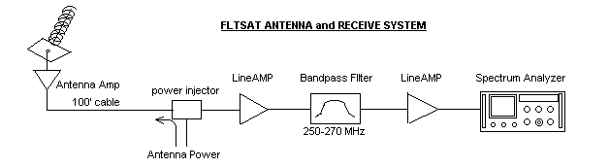
Each satellite supports 10 transponders or relay channels. The channels are encrypted, but we can see their amplitude and frequency on the spectrum analyzer (S/A) using the following procedures:
1) Set the SCAN WIDTH to 5 MHz/div and tune to 100 MHz. You should see the entire FM broadcast band and your favorite FM stations between about 98 to 108 MHz.
2) Now tune the S/A to 260 MHz and make sure the antenna is pointed at 220 degrees azimuth and about 40 degrees elevation. You should see the 10 channels from the USA FLEETSAT or UFO.
3) Now zoom in by changing the SCAN WIDTH to 2 MHz or less and you will notice that we are actually seeing 2 or 3 identical 10 channel sets slightly offset from each other, one from the original Fleetsat and the other from the UFOs sent up to replace it. Swing the antenna all the way to the East and lower in elevation and see if you can find a third Satellite (the Atlantic Satellite). The Pacific FLEETSATS are too low to our west to be seen from here. From geostationary altitudes, each satellite can see and service users on about 1/3rd of the planet.

