THERMAL Introduction:
Thermal design is one of the key factors in astronautics. In space, things gain heat from the Sun on one side, and lose heat to the blackness of space near absolute zero on the other. Maintaining a spacecraft at a reasonable temperature is one of the cornerstones of Astronautics.
As we know. Black things get hot in the sun and white things stay somewhat cooler. But on Earth, temperatures are moderated by the presence of air. The air will have a tendency to help cool things that try to get too hot and to warm things that try to get too cool. But in space, without the convecting currents of air, temperatures can get quite extreme.
ABSORBTIVITY:
The familiar heating of black objects in the sun compared to white objects is relative to the amount of absorbtivity of the surface. Black has about three times the absorbtivity of white. Hence it gets hotter. A shiny surface of aluminum is about equivalent to white and therefore only absorbs about the same amount of heat from the Sun. You would think it would be about the same temperature as white and much cooler than black. Such is not the case.
EMISSIVITY:
Although materials gain heat by absorbtivity, and of course lose some of that heat by convection with air, they also lose heat by radiation. Radiation is what you feel when you hold your hand near something that is warm and“feel” the heat. The efficiency with which materials can get rid of heat through radiation is a function of their emissivity. Interestingly, both black and white painted surfaces have about the same emissivity. But, amazingly, the emissivity of aluminum is only about 3% of that of black or white.
In space, without the heat transfer aspects of air, Absorbtivity and Emissivity are two of the primary factors in the temperature of materials. Make three basketball sized spheres of aluminum and paint one black, one white and one polished aluminum and place them in space about where earth is relative to the Sun. The black one will average to about a comfortable 55 degrees F. The white one will absorb less Sun, but still radiate the same as black to the coldness of space and so it will cool to about – 130 degrees F. Interestingly, the aluminum will also absorb the same less Sun as white, but because it cannot efficiently radiate the heat away, it will get very hot. Maybe as high as 250F degrees F! And yet all three space-balls are identical and in the same location and the only difference is their color!
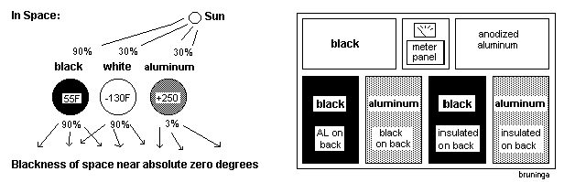
Experiment:
Six different types of materials and coatings are on display and each one is connected to a temperature sensor. Look at them and notice the temperatures recorded. Unfortunately, you will not see nearly as much difference in temperatures in air as you would see in space, but you will see some. And of course you have to have bright Sun to see any difference at all. All are insulated on the back.

BLACK

IRIDITED
ALUMINUM

WHITE

DULL
ALUMINUM

POLISHED
ALUMINUM

