WELCOME FUTURE ASTRONAUTS AND ASTRO ENGINEERS!

The Astronautic track in the Aerospace department exposes you to a full curriculum in spacecraft engineering culminating in student senior projects designing actual spacecraft. Six of the USNA satellites are shown below. Two are still in space, and four have returned to Earth. Several more projects are in work.

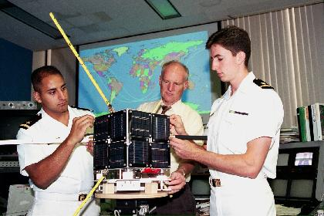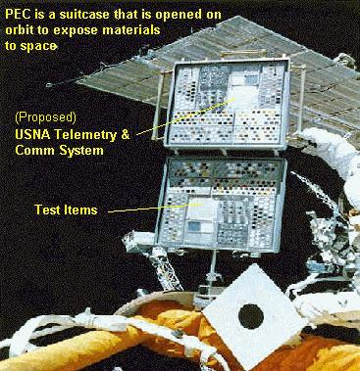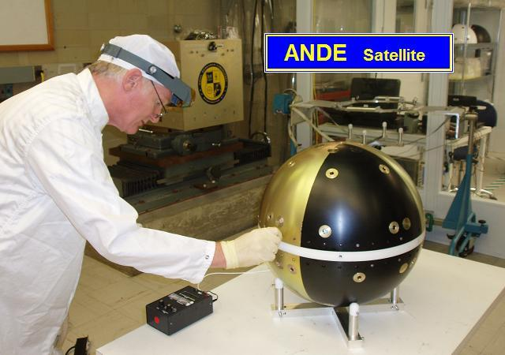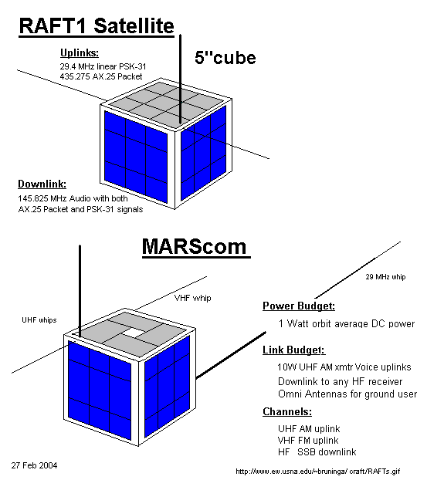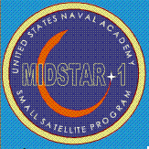
PCSAT-1 (Sept 2001) PCSAT2 (Jul 06) ANDE (Dec 06) RAFT (Dec 06) MIDSTAR (09/06)

During your 2 hour visit in our satellite labs, you will be get some hands-on experience with a number of satellite and space operations concepts at the stations as shown below. At each station, you are welcome to pick up additional handouts on each subject. On the web, start at www.ew.usna.edu/~bruninga/satstation.html

Rickover 119: Welcome, Power-point presentation
Rickover 121: Thermal and Vacuum chambers and Clean room
Rickover 122: Satellite Operations, PCSAT2 Satellite, ISS (if in view), Orbits (InstantTrack)
Rickover Lobby/Plazza Fleetsat/UFO reception, Antennas TV Satellites, GPS , Solar Power, Rocket Launch

Satellite Tracking: First you will look at some tracking programs. Satellites move in very predictable orbits following the laws of physics as long as there are no external forces acting on them, such as thrusters, or atmospheric drag. Computers can easily predict the locations of these satellites based on knowledge of their orbit.

The Low Earth Orbiting satellites called LEO’s are about 500 miles up and orbit the earth every 100 minutes or so. They come over Annapolis about 6 times a day each for about 8 to 15 minutes on each pass. It is interesting to notice that because of the geometry of low-earth-orbits, that LEO satellites spend most of their time in view relatively low to the horizon. Two-thirds of the time they are below 20 degrees. 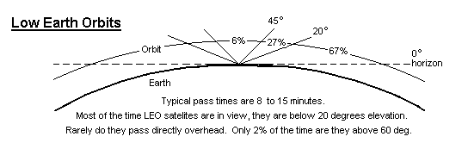
Navy FLEETSAT and UFO Satellites: The Navy uses a constellation of geostationary satellites called FLEETSATs. that operate on UHF frequencies. Recently the satellites have been upgraded with newer satellites called UHF-FOLLOW-ON satellites or UFO’s. These satellites are geostationary, meaning they appear at fixed points in the sky and can be used by ships, sailors and marines from anywhere. Look at the antennas on the ship models in the lobby. Sometimes on the news you may also see manpack antennas on vehicles in Iraq.
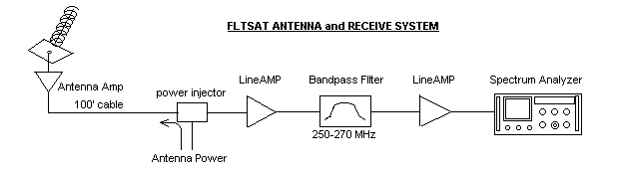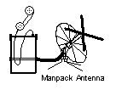
GPS Navigation Satellites: Man has used celestial navigation for thousands of years. Today’s Navy uses artificial stars (GPS satellites). The GPS receiver uses the time of arrival of atomic clock timing signals from at least four satellites to obtain a good “fix” on position and time. You will experiment with some GPS units.

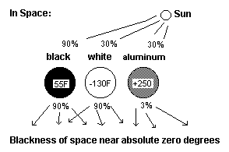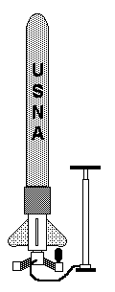
GPS Experiment Spacecraft Thermal Design Water Rocket

Water Rocket: We will do a rocket demo using an air pump to build up to a very high pressure in a special plastic soda bottle. When released, the pressure forces the water through the nozzle and the reaction force of this expelled mass propels the rocket .
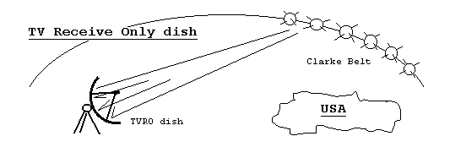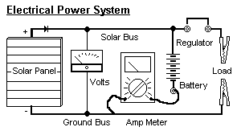
GEO Satellites: There are hundreds of TV satellites in a special orbit called Geostationary. The orbit takes exactly 24 hours so that the satellite appears to rotate with the Earth and therefore stays at one spot in the sky. This is a circular orbit above the equator with an altitude of 22,233 miles also known as the Clarke Belt. You will be able to point a dish and see how many satellites you can find. You may also experiment with Solar Power systems.
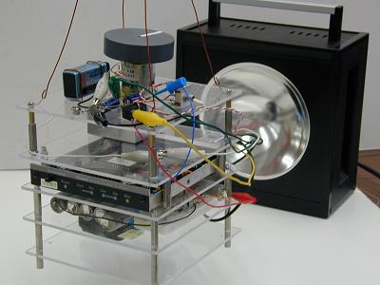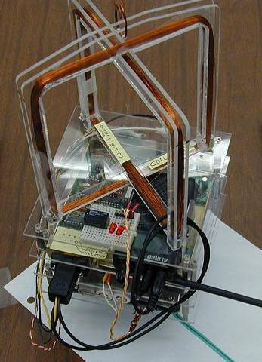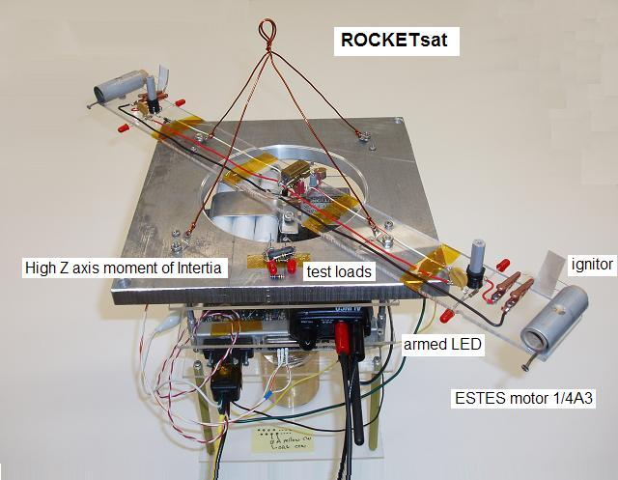
LAB Satellites: There are a lot of principles of spacecraft design, engineering and operations that we can actually demonstrate in the lab. Our students use a set of small satellites called LABsats to do experiments on electrical power, communications, attitude control, and telemetry, command and control. One of our satellites has a small TV camera to allow you to experiment with pointing an image sensor from a spacecraft.
*** Use your time in our Astronautics Department to learn about spacecraft and their
*** applications. You are welcome to pick up additional detailed handouts at each station.

